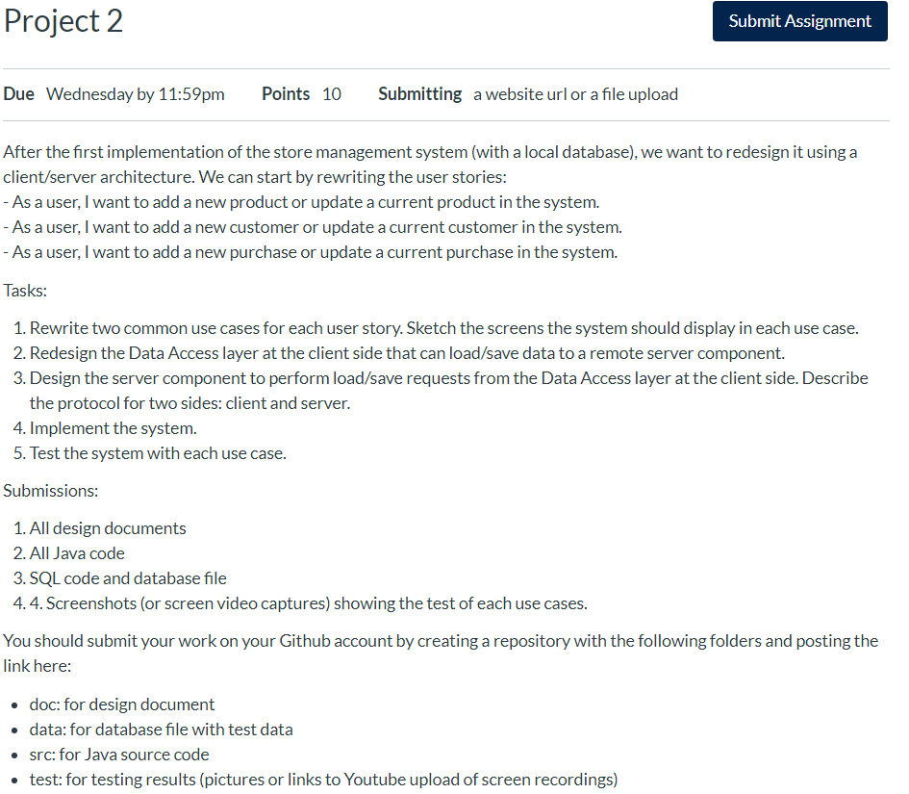

Tasks:

1. Rewrite two common use cases for each user story. Sketch the screens the system should display in each use case.

EACH USER STORY

- As a user, I want to add a new product or update a current product in the system.

2 use cases could be a manager adding a new product, or editing and existing product

- As a user, I want to add a new customer or update a current customer in the system.

2 use cases could be management adding a new customer, or updating customer information

- As a user, I want to add a new purchase or update a current purchase in the system.

2 use cases could be a customer adding a new purchase or updating a current purchase in the system

1. Redesign the Data Access layer at the client side that can load/save data to a remote server component.

This picture is the output from the client side of the implemented Data Access layer that can load/save data to a remote server component shown below in the second figure.

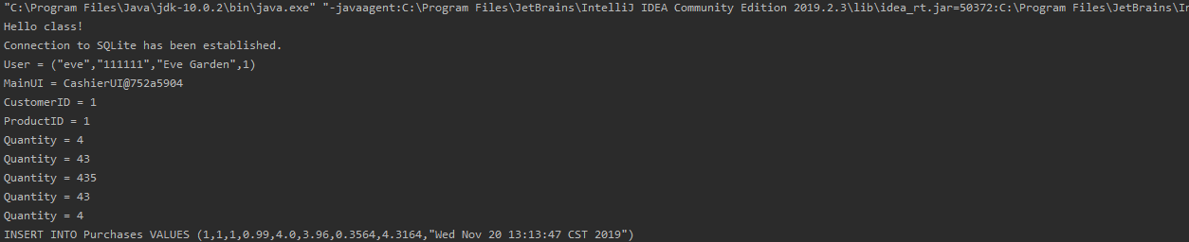

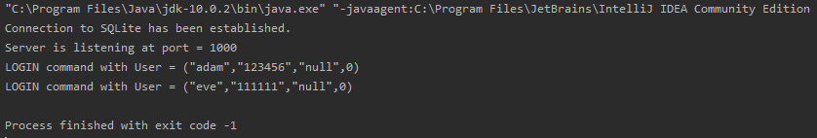

1. Design the server component to perform load/save requests from the Data Access layer at the client side. Describe the protocol for two sides: client and server.

The picture of the server component output when used to perform load/save requests is seen above in the second figure of question 2. The protocol for the two sides is that the client sends a username and password to the server and the server either approves or denies the login request based on its SQL database. From that point the client opens up specific UI for specific user types that can be used as a visual interface to send commands to the server.

1. Implement the system.

DONE!

1. Test the system with each use case.

DONE! Pictures are in the pictures folder labeled test